**Lab Report**

Title: Developing a Deterministic Model for Identifying “Stroads” in Minneapolis

Notice: Dr. Bryan Runck

Author: Holly Leaf

Date: 12/22/21

**Project Repository:**<https://github.com/hleaf/GIS5571/Final_Project>

**Google Drive Link:** <https://drive.google.com/drive/folders/1lea3KWCeRySoBFKrjV-_cMe5QphtozUz?usp=sharing>

**Time Spent:** ~35 hours

The term “stroad”, coined by former traffic engineer and writer Charles Marohn in 2011, has gained attention in urbanist circles in recent years. A stroad is defined as a type of roadway that is a cross between a street and a road. Marohn defines a stroad as a high-speed road with many turnoffs and which lacks safety features including pedestrian infrastructure and traffic calming measures. Stroads are common in the United States, particularly in suburban areas.

The term stroad is one which lacks any agreed-upon classification. It is more of a “I know it when I see it” type of definition. In this project, I hope to provide a GIS model for the classification of stroads, and then to determine the extent to which stroads can be found in the city of Minneapolis and/or Hennepin County.

An inspiration for this project was my presentation topic, the paper by Purciel et al. (2009) which used GIS methods to create and validate a model for analyzing urban design elements. The scope of that paper is far beyond what I am capable of doing for this course, so I opted to look for a “simpler” project. Another inspiration is the Vision Zero initiative that has been adopted by the City of Minneapolis, which aims to reach zero traffic deaths through various safety methods including redesigning streets.

**Problem Statement**

This paper will provide a deterministic model for classifying a stroad from other roadway types (streets and roads), and apply that model to determine the extent to which stroads can be found within Minneapolis.

The issue with stroads is that they do not do a good job either efficiently and quickly moving traffic (i.e., roads) nor do they provide a safe and accessible urban environment for a variety of uses (i.e., a street). Instead they are inefficient, slow, dangerous, and expensive. Another issue is that they necessitate a large amount of space dedicated to moving cars at the expense of other modes of transportation or denser land use patterns. This leads to car-centric land use patterns like big box stores and large surface parking lots to the detriment of pedestrians, cyclists, and transit users.

Classifying roadways as streets, roads, or stroads can help to find areas of opportunity for road redesigns, road diets, land use changes, or other interventions. Turning stroads into streets or roads allows roadways to serve a specific purpose of either supporting public life or efficient automobile transportation, respectively. Both of these roadway types are better served for their intended purpose compared to stroads. They are also significantly safer, which is important for meeting the City of Minneapolis’ Vision Zero goals of zero traffic deaths in the city.

By creating a deterministic model to identify stroads, an entire city or region can be analyzed at once. This allows planners and traffic engineers to easily see road type patterns in their regions. Qualitative methods of identifying stroads are slow and expensive. This model will allow for analysis to be done and re-done quickly with only relatively simple data sources. It also allows for a more objective classification method for roadway type.

A few examples of streets, roads, and stroads in Minneapolis can be found below in Figure 1. Stroads tend to have many traffic lanes, street-facing buildings, mid-to-high speed limits, and little pedestrian infrastructure.

*Figure 1. Roadway type examples in Minneapolis (source: Google Maps)*

**Streets:**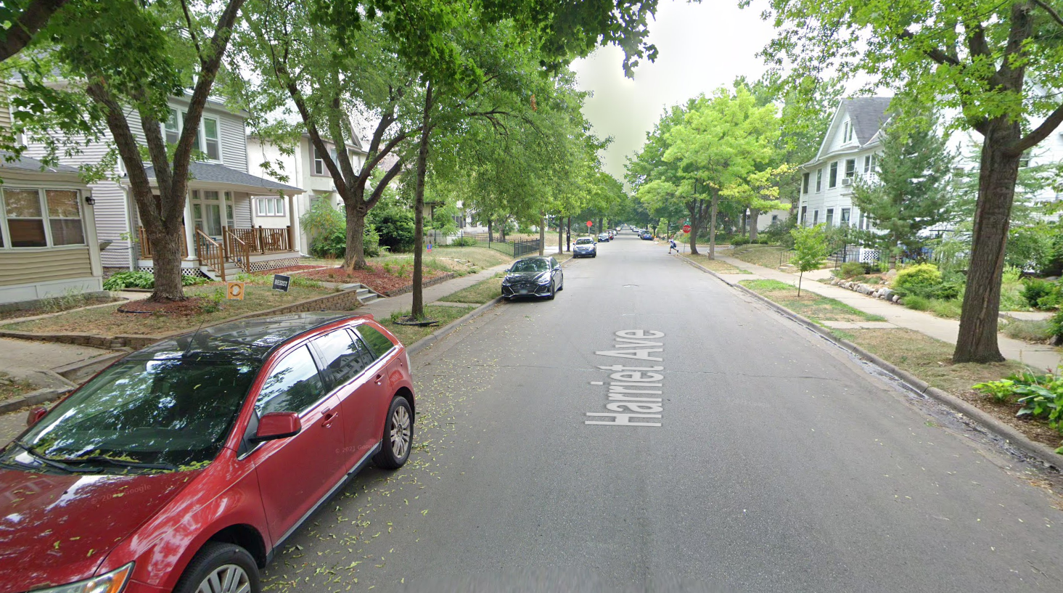

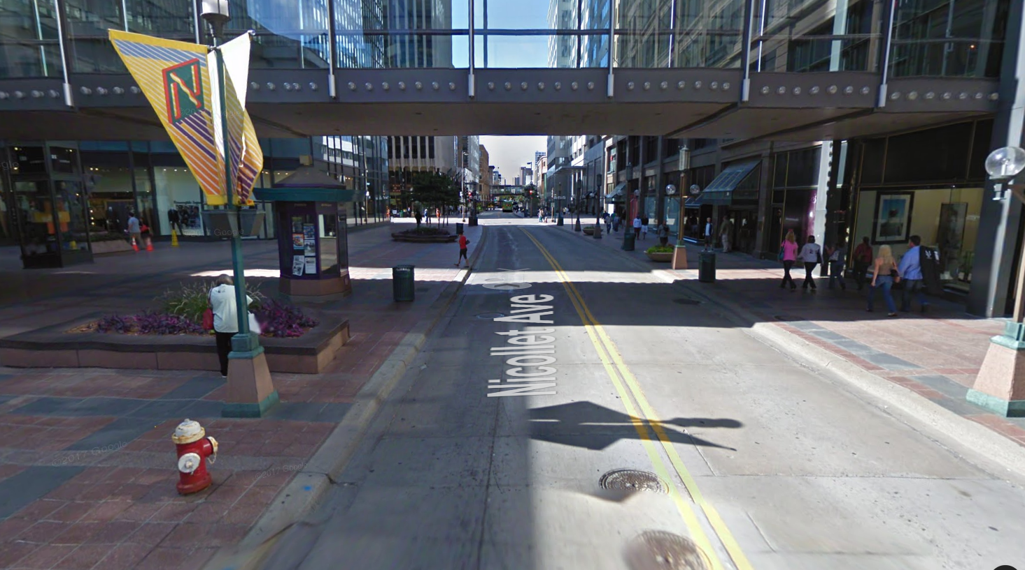

**Roads:**

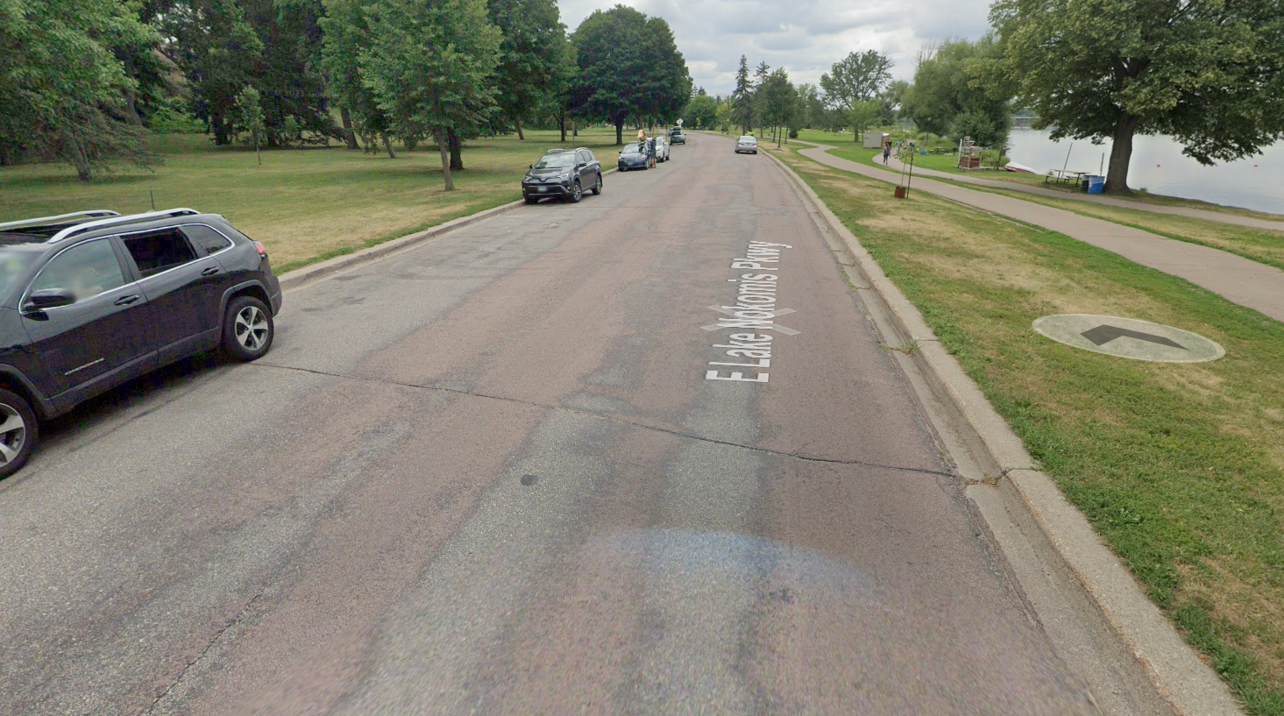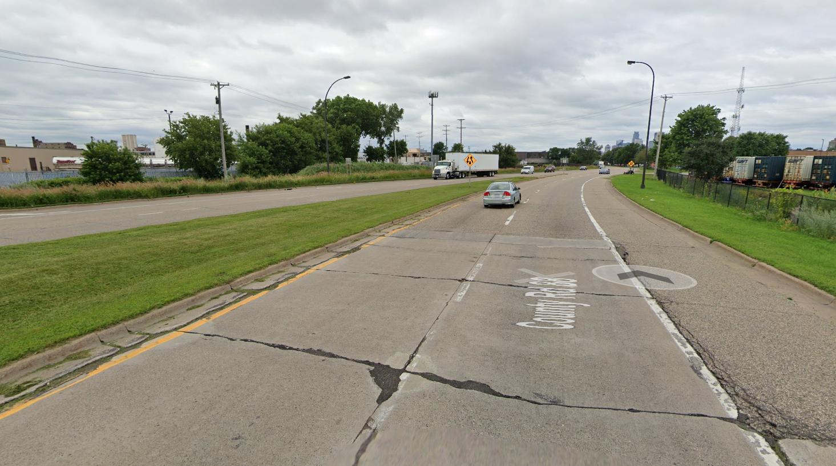

**Stroads:**

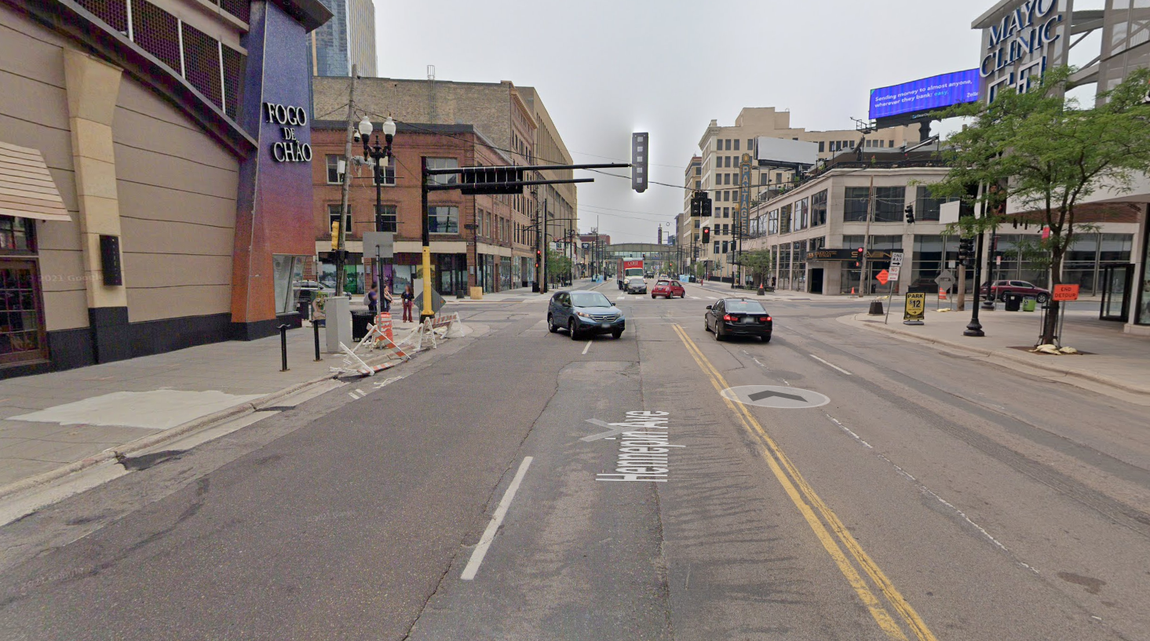

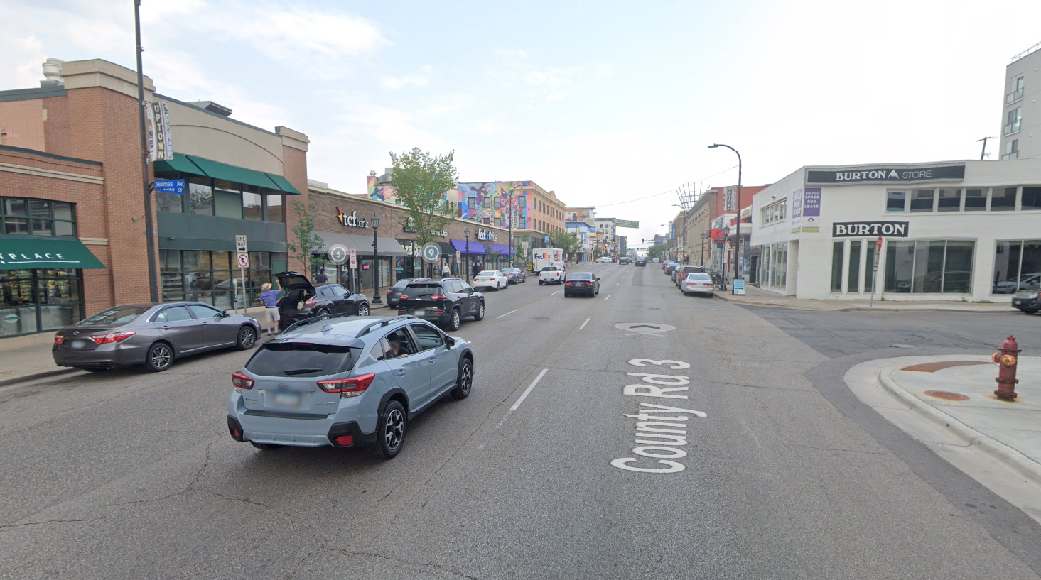

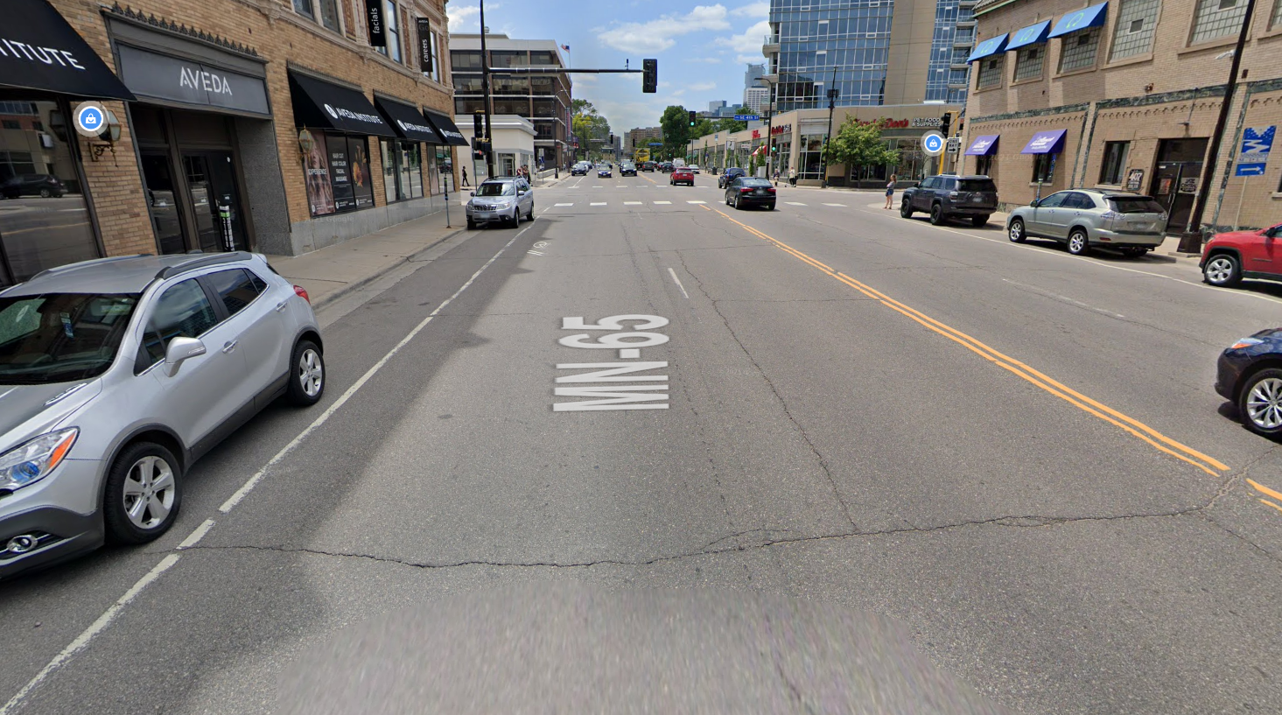

Data used in the model includes roadway lane information and road centerlines for Minnesota, speed limits for Minneapolis roads, address points in Hennepin County, and the Minneapolis city boundary for defining spatial extent.

*Table 1. Raw input data*

|  |  |  |  |  |  |  |
| --- | --- | --- | --- | --- | --- | --- |
| **#** | **Requirement** | **Defined As** | **(Spatial) Data** | **Attribute Data** | **Dataset** | **Preparation** |
| 1 | Roadway Lane Information in MN | Detailed information on roadway lanes in Minnesota. | n/a | Number of through lanes. Route IDs. | [MnGeo (MNDOT)](https://gisdata.mn.gov/dataset/trans-lanes) | Attribute join to route centerlines |
| 2 | MnDOT Route Centerlines | Road centerlines for all roadways in Minnesota | MN Roadways | Basic roadway identification and attributes. | [MnGeo (MNDOT)](https://gisdata.mn.gov/dataset/trans-roads-centerlines) | Attribute join to lane information |
| 3 | Minneapolis Speed Limits | Speed limits for road segments in Minneapolis as of 12/2020 | MPLS road segments | speed limits | [City of Minneapolis](https://www.arcgis.com/home/item.html?id=6e39fa419da74af7b11390e848b04a0c) | Spatial join to route centerlines |
| 4 | Hennepin County Address Points | Address points in Hennepin County | Address points | n/a | [Hennepin County Open Data](https://gis-hennepin.opendata.arcgis.com/datasets/address-points/explore?location=45.015479%2C-93.473100%2C10.67) | Clipped to Minneapolis city boundary |
| 5 | Minneapolis City boundary | MPLS city boundary | city boundary polygon | n/a | [Minneapolis Open Data](https://opendata.minneapolismn.gov/datasets/city-boundary/explore?location=44.970914%2C-93.261718%2C12.81) | n/a |

**Input Data**

There are five raw input datasets used for the model. These include: roadway lane information to identify the number of traffic lanes on a road segment; MnDOT roadway centerlines for basic attribute data and the spatial data for roads; Minneapolis speed limits; Hennepin County address points for determining street-facing address density on road segments; and Minneapolis city boundaries for defining spatial extent in the analysis.

*Table 2. Input Data*

|  |  |  |  |
| --- | --- | --- | --- |
| **#** | **Title** | **Purpose in Analysis** | **Link to Source** |
| 1 | Roadway Lane Information in MN | Dataset for roadway lane details courtesy of MnDOT | [MnGeo (MNDOT)](https://gisdata.mn.gov/dataset/trans-lanes) |
| 2 | MnDOT Route Centerlines | Spatial and basic attribute data for Minnesota roads. Used as the primary spatial layer. | [MnGeo (MNDOT)](https://gisdata.mn.gov/dataset/trans-roads-centerlines) |
| 3 | Minneapolis Speed Limits | Minneapolis speed limits by road segment for classification. | [City of Minneapolis](https://www.arcgis.com/home/item.html?id=6e39fa419da74af7b11390e848b04a0c) |
| 4 | Hennepin County Address Points | Address points to calculate address point density by road segment | [Hennepin County Open Data](https://gis-hennepin.opendata.arcgis.com/datasets/address-points/explore?location=45.015479%2C-93.473100%2C10.67) |
| 5 | Minneapolis City boundary | To clip layers to the spatial extent (Minneapolis) | [Minneapolis Open Data](https://opendata.minneapolismn.gov/datasets/city-boundary/explore?location=44.970914%2C-93.261718%2C12.81) |

**Methods**

The working model (Figure 2) involves classification by road segment based on speed limit, address point density, and number of through lanes. An ETL was created in Python to run all steps of the data flow model, including downloading the raw input data. This ETL allows analysis to be re-run quickly as data changes. It also allows for this model to be adapted to other cities or regions if these simple data layers are available.

*Figure 2. Working data flow diagram*

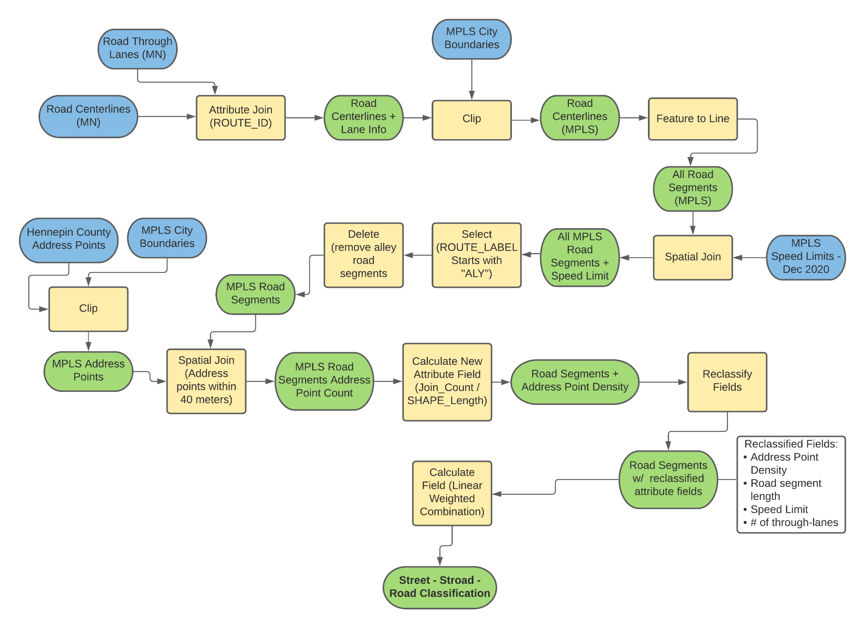

The current working model is as follows:

1. Attribute join to join roadway lane information with road centerlines using ROUTE_ID attributes (both from MnDOT).
2. Using the Minneapolis city boundary data to clip the spatial extent of the roadway layer.
3. Feature To Line tool used on the road centerlines layer to split roadways into segments at all intersections. This allows analysis to be performed on each segment of roadway separately, rather than evaluating the entire length of a roadway.
4. Spatially joining road segments with Minneapolis speed limits, to be used in final classification.
5. Selecting and then deleting routes with labels that begin with “ALY”, which is the MnDOT code for alleys. Alleys will not be evaluated and just clutter up the analysis.
6. Clipping Hennepin County address points to limit analysis to Minneapolis city boundaries.
7. Spatially joining road segments with address points to get a count of address points that are within 40m for each road segment. This distance was chosen because it was a good distance to include almost any address point which faced that street, while not including any address points that are too far away from the street to be considered to be on that street.
8. Calculating a new field for address point density (join count from previous step divided by road segment length). This is used to normalize the address point counts to factor in differing road segment lengths.
9. Reclassification for fields including: address point density, speed limit, and # of through lanes for each road segment. Each attribute field was reclassified on a scale of 1 to 10 (1 being most “street-like” and 10 being most “road-like”). Address point density is lower on roads and higher on streets. Speed limit is higher on roads and lower on streets. Number of lanes is higher on roads and lower on streets.
10. Calculating a 1 to 10 classification for all road segments using linear weighted combinations of the fields listed in the previous step. Weights were equal (⅓) in the working model, but will be re-weighted as the final model is developed.

**Results**

Figure 3 shows the current results for the working model. In this map, cyan road segments have been classified as streets, purple road segments have been classified as roads, and red road segments have been classified as stroads. Streets were classified as any road segments with a score of 3.5 or less on the 10-point scale. Stroads were classified as road segments with a score between 3.5 and 6. Roads were classified as road segments with a score over 6. These classes were chosen somewhat arbitrarily, but it appeared to fit the author’s understanding of road segments in the Twin Cities best. The 1-to-10 score is the best indicator, but for ease of readability it was important to create as few classifications as possible for the map.

While this is a good start, there are some clear aberrations in the model which will need to be addressed as the model is further developed. For example, roads around parks and lakes tend to get classified as stroads, but they don’t particularly fit that classification. This is due to relatively low speeds and number of lanes coupled with a low address point density (there usually aren’t many addresses on a lake or golf course). Similarly, road segments on university campuses such as the University of Minnesota were generally classified as stroads despite many of these streets being pedestrian-oriented. This is likely due to the low density of address points on campus combined with slow speed limits and single-lane roads.

Most classifications seem to fit at a glance, however. Residential streets are primarily classified as streets. Downtown streets and major corridors are classified as stroads, and highways are classified as roads. Model verification using observational methods (see *Results Verification* below) suggests that the model is largely valid for predicting road segment types.

*Figure 3. Preliminary results*

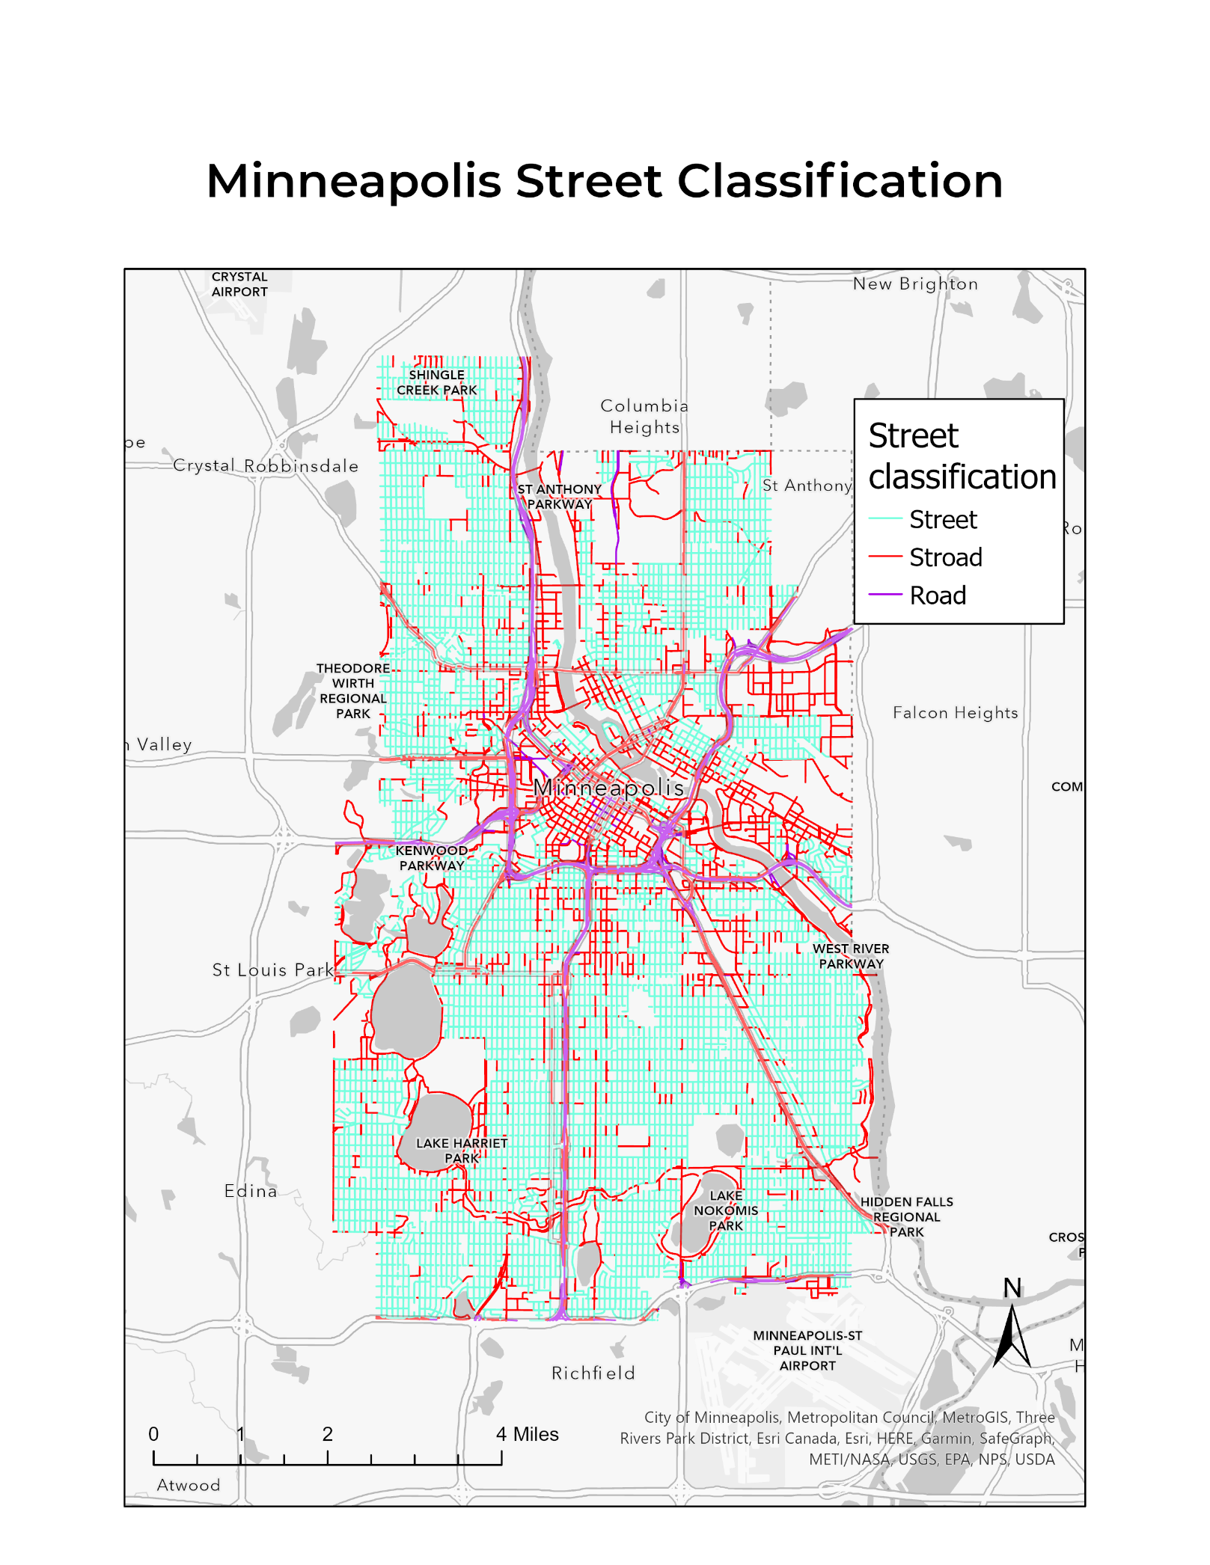

**Results Verification**

The stroad classification model was validated against observational methods. Stratified random sampling was used to get a randomized sample of 30 road segments that were classified by the model as roads, streets, and stroads, for a total of 90 road segments in the sample. When purely random sampling was attempted, the sample was heavily skewed towards residential streets because of the sheer number of these roadways relative to other right-of-ways.

Each of these sample road segments was classified (using the same 1 to 10 scale of street to road) by observational methods. Google Maps Street View was used to evaluate each road segment by an expert observer (the author). Observational methods used more indicators for analysis than the GIS model, including pedestrian infrastructure, traffic calming measures, sense of enclosure, lane width, turn lanes, and parking lanes. Observational classifications were made without knowing the GIS model classifications.

After observational classifications were made, they were compared against the GIS model classifications for the 90 sample segments. A Pearson’s correlation coefficient and a Spearman’s rho were calculated to test the validity of the model against observational methods. Classification numbers for each road segment were charted along with a line of best fit (**Figure 4**). These correlations indicate a strong correlation between the model and observational classification methods, thus validating the model.

**Pearson’s Correlation**

r = 0.874006

p-value < 0.00001

**Spearman’s Rho**

rs = 0.86076

p (2-tailed) = 0

*Figure 4. Observational vs. GIS model classifications*

**Discussion and Conclusion**

Based on the results verification, the model seems to be significantly predictive in classifying roadways along a spectrum of street-to-stroad-to-road. However, there are still some aberrations in the model results which could be addressed with additional data layers. Part of the model’s strength is its simplicity which allows for it to be adapted to other regions easily. This should be considered with any additional complexity added to the model in the future. With that in mind, there are some possible areas of improvement for the model.

As mentioned previously, roadways around green space tend to be misclassified as stroads due to low address point density combined with slow traffic and low number of through lanes. This could be corrected for using an analysis layer of land use classifications to identify open water and green space. Additionally, roadways on university campuses are classified as stroads for similar reasons. This could be addressed using LiDAR data to determine enclosure based on building heights and setbacks in addition to address point density.

As mentioned in *results verification*, observational methods used additional indicators including pedestrian infrastructure, traffic calming measures, sense of enclosure, lane width, turn lanes, and parking lanes. The additional roadway information could be added to the model with data available from MnDOT. Enclosure could be addressed using LiDAR data to determine building height and setbacks.

While these improvements could help to further develop the model to make it more effective, the results are successful at classifying stroads, roads, and streets. This model is a useful exercise in analyzing right-of-way design across Minneapolis. Further development of the model should not overcomplicate the model, but strive to patch some of the holes in the model as identified above.

**References**

Marohn, C. (2020, July 27). The Stroad. Strong Towns. <https://www.strongtowns.org/journal/2017/10/30/the-stroad>

Purciel, M., Neckerman, K. M., Lovasi, G. S., Quinn, J. W., Weiss, C., Bader, M. D., Ewing, R., & Rundle, A. (2009). Creating and validating GIS measures of urban design for health research. *Journal of environmental psychology*, *29*(4), 457–466. <https://doi.org/10.1016/j.jenvp.2009.03.004>

**Self-score**

|  |  |  |  |
| --- | --- | --- | --- |
| **Category** | **Description** | **Points Possible** | **Score** |
| **Structural Elements** | All elements of a lab report are included **(2 points each)**:  Title, Notice: Dr. Bryan Runck, Author, Project Repository, Date, Abstract, Problem Statement, Input Data w/ tables, Methods w/ Data, Flow Diagrams, Results, Results Verification, Discussion and Conclusion, References in common format, Self-score | 28 | **28** |
| **Clarity of Content** | Each element above is executed at a professional level so that someone can understand the goal, data, methods, results, and their validity and implications in a 5 minute reading at a cursory-level, and in a 30 minute meeting at a deep level **(12 points)**. There is a clear connection from data to results to discussion and conclusion **(12 points)**. | 24 | **20** |
| **Reproducibility** | Results are completely reproducible by someone with basic GIS training. There is no ambiguity in data flow or rationale for data operations. Every step is documented and justified. | 28 | **28** |
| **Verification** | Results are correct in that they have been verified in comparison to some standard. The standard is clearly stated **(10 points)**, the method of comparison is clearly stated **(5 points)**, and the result of verification is clearly stated **(5 points)**. | 20 | **20** |
|  |  | 100 | **96** |